Arab Open University

Lebanon Branch

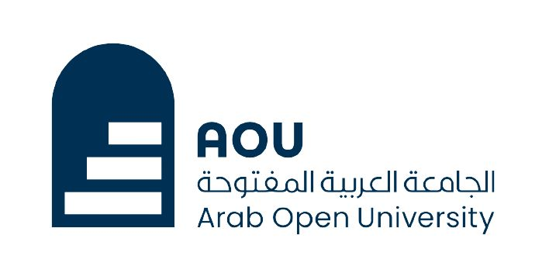

Faculty of Computer Studies

Data Science Program

TM471: Graduation Project

***Water Scarcity in the Arab world***

**Name:** Rony Al Moussa

**Id:** 220339

**Supervisor:** Dr. Maya Dawood

05/ 2024

**My linkedin video:**

<https://www.linkedin.com/posts/roni-almoussa-27942a23a_my-final-project-video-all-the-needed-information-activity-7191457781885861889-VFzo?utm_source=share&utm_medium=member_desktop>

**My cv:** (you can also find my cv in my linkedin profile)

Rony Al Moussa

**Phone number:** (+961) 81369427

**Email address:** [ronialmoussa1234@gmail.com](mailto:ronialmoussa1234@gmail.com)

**Home:** Qaaqour, Lebanon

# OBJECTIVE

Highly motivated and results-oriented individual with a strong desire to gain experience in Data Science. Eager learner with exceptional problem-solving skills, seeking to leverage these abilities in a programming role to continuously develop my technical expertise.

# EXPERIENCE

## Freelance Project: (2024 - Present)

* Developing a web application that analyzes LinkedIn data and generates visualizations to empower users with insights into their network and career opportunities.

## Waiter at La Boheme (2022 – 2024)

* Leveraged strong customer service skills to deliver exceptional guest experiences in a fast-paced environment.
* Prioritized tasks and managed multiple tables efficiently, ensuring accuracy and timely service.
* Analyzed customer preferences to optimize menu recommendations.

## Outdoor activities staff:

* Effectively instructing participants, fostering a positive and inclusive environment, and potentially dealing with diverse age groups.
* I likely had to take initiative in some situations, guide participants, and ensure safety. This translates to leadership abilities.
* Unexpected situations might arise outdoors. Demonstrating resourcefulness and ability to solve problems on the fly is valuable.

# EDUCATION

## Bachelor's in Data Science

***Arab Open University- AOU*** (25/09/2021 – Current (last semester))

* Led a final project on water scarcity in the Arab world, utilizing data analysis techniques to extract insights and predict future trends.

**Aptis grade: C**

## High school certificate, sv

***Dhour Choueir public secondary school*** (25/09/2018 – 15/06/2021)

# SKILLS

## Technical Skills:

|  |  |
| --- | --- |
| * Python | * R language |
| * C# | * Jupiter |
| * Data structure and algorithm | * Microsoft Office (Word, Excel, Power Point) & Microsoft Power Bi |
| * Database knowledge and SQL | * Machine Learning & Artificial Intelligence |
| * Applied Statistical Modeling & Hypothesis Testing | * Training in photoshop |

**Soft Skills**

* + Problem Solving

**LANGUAGE SKILLS**

**Arabic, English & French**

* + Analytical skills
  + Communication skills
  + Team working skills